General idea

Despite Ni’s biogeochemical importance, we have a poor understanding of its marine cycling, even in the modern oceans. In 1976, Krishnaswami (Krishnaswami, 1976), identified a massive Ni mass imbalance. In the several decades that have followed, we have yet to resolve the imbalance. Currently, our best estimates indicate that Ni sink fluxes from the ocean are twice the size of source fluxes (Ciscato et al., 2018; Gall et al., 2013; Sclater et al., 1976). If this were true, the ocean would be rapidly depleted in Ni, but there is no evidence for such deviation from steady. Once the modern marine Ni budget is balanced, we will have identified the key modern controls of marine Ni cycling and this will enable robust modelling of the marine Ni cycle, and the subsequent affects, over time.

**Inputs**

**Dust**

To estimate the Ni contribution to the oceans from dust, we must know the yearly deposition of dust, the average concentration of Ni in dust, and the percent of that Ni which ultimately dissolves in the ocean. An estimated 450 Tg of dust is deposited in the ocean every year (Jickells et al., 2005 and references therein). Although there are significant anthropogenic Ni contributions to modern aerosols (Desboeufs et al., 2005; Galloway et al., 1982; Nriagu, 1989), considering Ni has a residence time on the order of 10,000 years, the natural contributions are likely most relevant to the modern marine budget. Assuming the upper continental crust is compositionally similar to dust, the [Ni]upper continental crust, and therefore [Ni]dust, is 47 ppm (Rudnick and Gao, 2014). To approximate the fraction of Ni that will dissolve, represented here as the amount of Ni dissolved divided by the total Ni in bulk aerosol, several studies have performed leaching experiments with loess (Desboeufs et al., 2005) or particles filtered from air at coastal or island stations (Fishwick et al., 2017; Mackey et al., 2015) using leachates such as ultra-high purity water or filtered seawater. The percent of dissolved Ni ranges from 1 to 86% and appears to be primarily dependent on material provenance rather than leachate, regardless of oxygen content, pH, or temperature (Desboeufs et al., 2005; Fishwick et al., 2017; Mackey et al., 2015). The wide range in solubility may be due to variable anthropogenic contributions. A study seasonally sampled aerosol samples and found that increases in anthropogenic input, conventionally identified by an enrichment factor relative to continental crust greater than 10 (Jickells et al., 2016), correlated with increases in solubility (Hsu et al., 2005). To avoid potential anthropogenic contributions, I conservatively opt to use the dissolution value of 2% from Desboeufs et al. (2005), which used Loess from Cape Verde as the leached material, rather than studies which used modern aerosols and may be influenced by anthropogenic particles. The total yearly Ni input to the oceans from dust is then 7.2x106 mol/yr.

* Papers to read/reference for dust
  + A global assessment of natural sources of atmospheric trace metals by Nriagu 1989 – estimates Ni flux from natural and anthropogenic emissions as 30x109 g/yr and 56x109 g/yr. Not sure what % gets to ocean and then is soluble
  + Trace metals in atmospheric deposition: A review and assessment by Galloway et al. 1982 – estimates Ni flux from natural and anthropogenic emissions as 28x109 g/yr and 98x109 g/yr. Not sure what % gets to ocean and then is soluble
  + Atmospheric transport of trace elements and nutrients to the oceans by Jickells et al. 2016
    - So basically, Ni likely has some signficant anthropogenic contributions because it has a high EF and is primarily associated with smaller particle sized aerosols which are more charcteristic of high temperature anthropogenic processes. Figure 5 shows the generally low solubility of these emissions. I think this is all about dry deposition, not wet (e.g.rain I think). Does this matter for the budget? I'd guess no because it's only in the last 100 years or so that this mattered and Ni has a residence time on the order of 10ky.
    - Graphical user interface, application

      Description automatically generated
    - 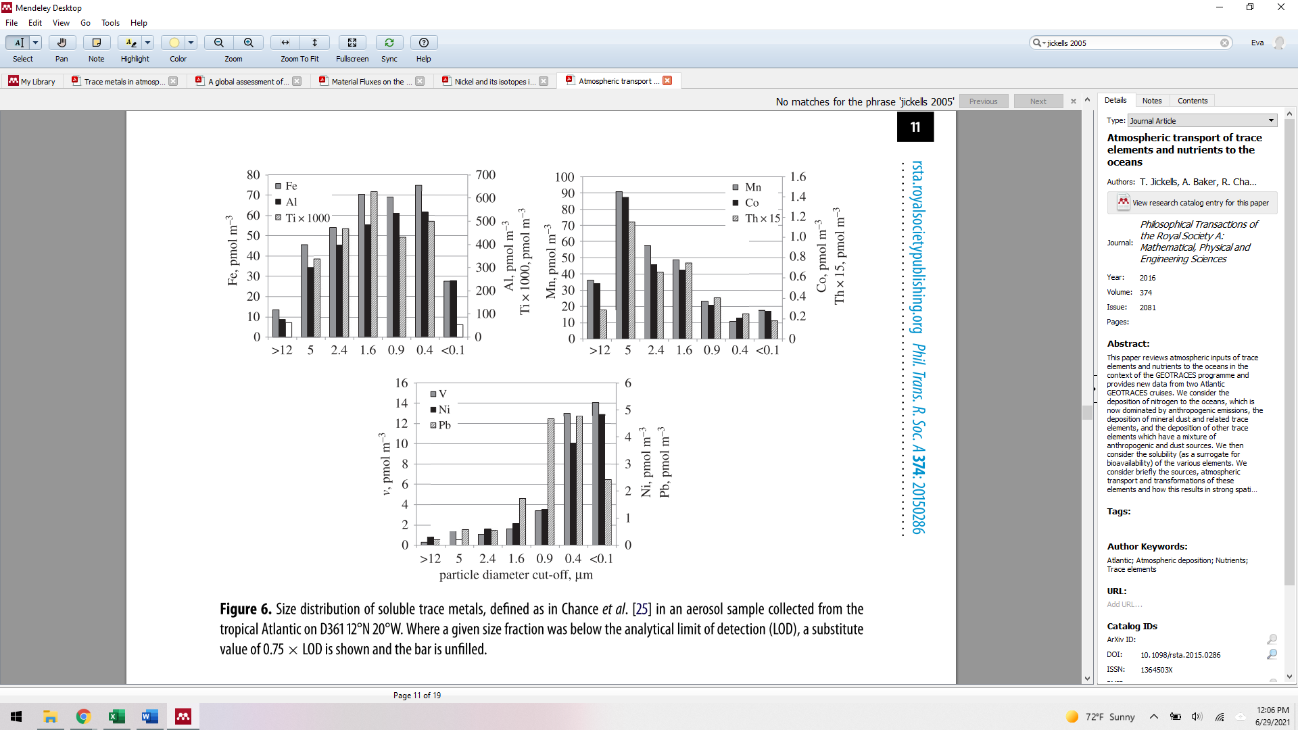
    - See Aerosol size-resolved trace metal composition in remote northern tropical Atlantic marine environment: case study Cape Verde islands by Fomba et al 2013 for case study data
  + Global iron connections between desert dust, ocean biogeochemistry, and climate by Jickells et al 2005
    - Used by ciscato et al 2018 (and I believe subsequent Vance papers) to estimate the atmospheric dust input to the ocean (450 Tg/year). It is unclear to me if this includes wet and dry deposition since I think dust can be deposited by rain from the atmosphere.
    - 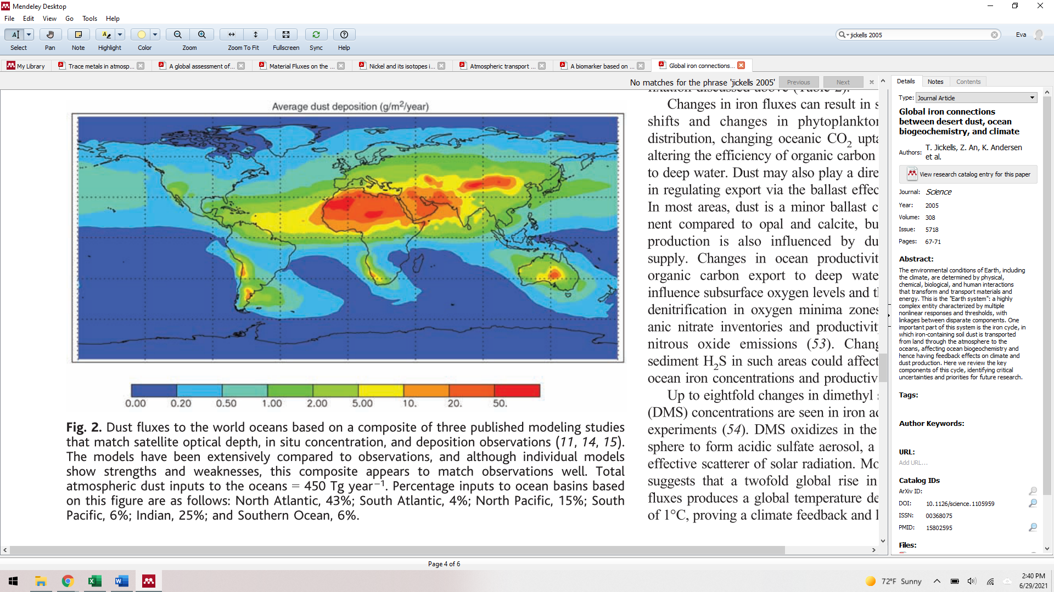
  + Rapid and gradual modes of aerosol trace metal dissolution in seawater by Mackey et al 2015
    - The components that are soluble from dust is what’s relevant for precipitation from solution (I think) and is what is bioavailable
    - Dust collected over 3 days several times over the course of many months at the shoreline of the Gulf of Aqaba, Red Sea at the Inter-University Institute for Marine Science (29◦31?N, 34◦55?E). Leached in aged filtered seawater with known metal quantities.
    - Nickel showed gradual dissolution (see figure 2 below) with 12% dissolved after 10 minutes and 25% dissolved after 7 days (with 10 and 13% uncertainty).
    - 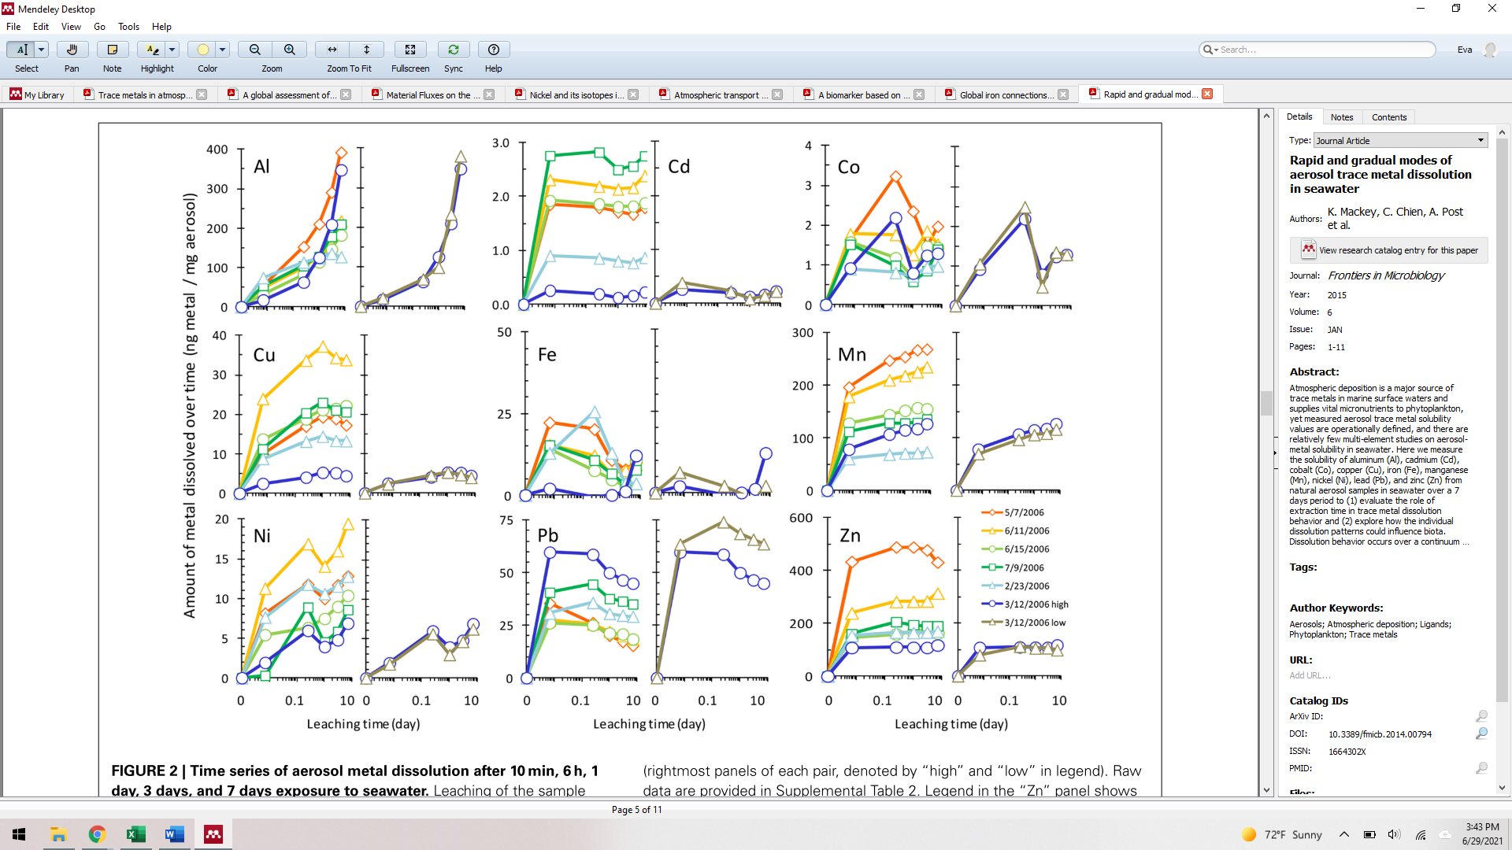
  + Dissolution and solubility of trace metals from natural and anthropogenic aerosol particulate matter by Desboeufs et al. 2005
    - Ciscato et al 2018 used this paper to calculate the % solubility of Ni for dust
    - The paper took several natural and anthropogenic sediment types and then subjected them to MilliQ water acidified with sulphuric acid “which is a typical atmospheric acidifying agent (Fuzzi, 1994). The pH is fixed to 4.7” in an open flow reactor. For Loess from Camp Verde, they found a 2% dissolution of Ni after 120 minutes. They stated that 90% of the total dissolved content is released within 20 mintutes of dissolution regardless of particle type.
  + Impact of surface ocean conditions and aerosol provenance on the dissolution of aerosol manganese, cobalt, nickel and lead in seawater by Fishwick et al 2017
    - This study collected aeorsal samples 4 times (AER1 and AER2 correspond to primarily natural dust while AER3 and 4 correspond to combination/primarily anthro dust) from the Tudor Hill atmospheric observatory on the southwest coast of Bermuda and leached them (up to 30d) with seawater under varying O2 levels, pH, temperatures, and organic ligand content to determine the impact of these variables on the % dissolved and colloidal fractions of several metals. They found that, of the total dissolved Ni (<0.4 μm), it was pretty evenly split between the colloidal (0.02–0.4 μm) and soluble fraction (<0.02 μm). Temperature, pH and O2 did not have a statically significant control on the dissolution of Ni. For Ni, the difference in total amount of dissolved Ni and the soluble Ni for the different organic ligand treatments was not statistically significant. The %Ni dissolved relative to the total Ni in the aerosol sample was 40 to 85%.
    - 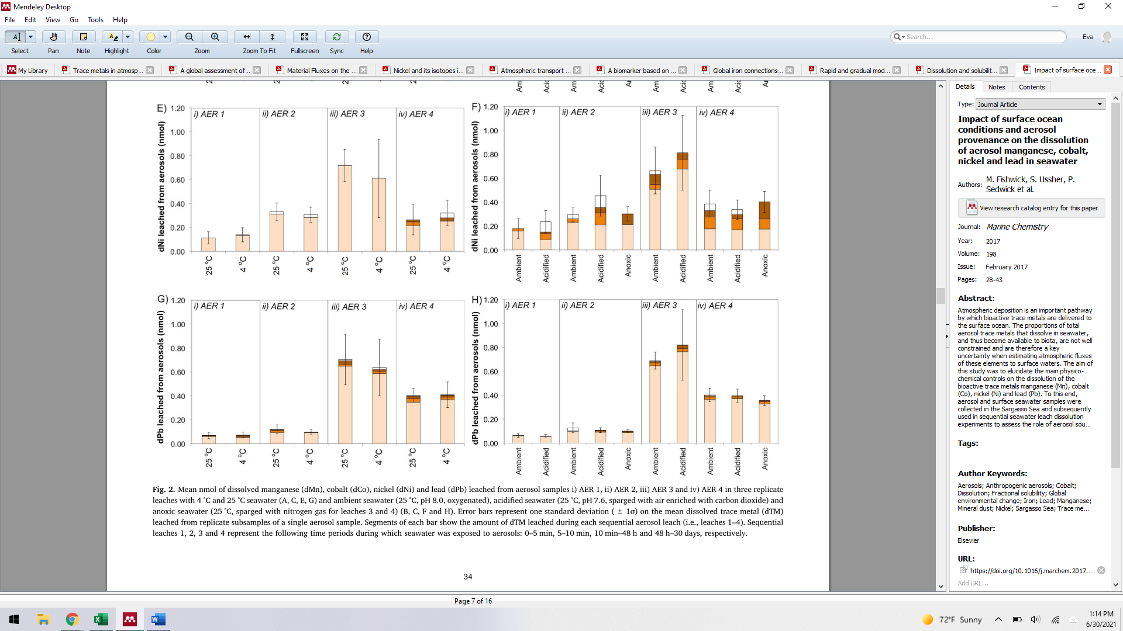

**Rivers [particulate and dissolved]**

Dissolved load

Similarly, to calculate the riverine input of Ni, we need to know the annual riverine discharge and the Ni content of these rivers, with a focus on the dissolved load (which will be defined as the remaining Ni in solution after being passed through a 0.2 micron filter). The estimated annual total discharge for rivers is 3.6–3.8 × 1016 kg (references within berner and berener, Dai). The average riverine dissolved Ni concentration has been updated several times, but varies little. An early estimate from Martin and Whitfield 1983 and references therein suggested the average riverine Ni concentration was 8.5 nmol/L. Gaillderat (2003) aggregated concentration and discharge data for >30 rivers and calculated 13.6 nM as the average riverine dissolved Ni concentration. Cameron and Vance 2014 calculated the abundance weighted average concentration of dissolved Ni from 8 rivers, which constitute 20% of the total riverine discharge, to be 9.6 nM. Given the homogeneity of these estimates and the similar nature of their estimation, we simply propose a range for total Ni discharge is between approximately 3.1x108 to 5.2x108 Ni mol/year, two orders of magnitude greater than dust.

Suspended particulate load

* The suspended particulate load (SPL) of rivers has been suggested as potential resolution to the mass and isotope imbalance, but there are two problems (1) the debated size this flux and (2) the generally isotopically light composition of the known components. The SPL consists of a variety of particles (*e.g.,* clays, carbonates, Fe and Mn oxyhydroxides, organic complexes) which can contain a significant fraction of the total riverine load for a given metal (Gaillardet et al., 2003; Gibbs, 1973). A handful of studies have calculated the SPL Ni/dissolved Ni in a variety of rivers and determined a wide range of values (0.4x to 40x), with a large portion hosted by Fe and Mn oxyhydroxide phases (Gibbs, 1977, 1973; Revels et al., 2021; Seyler and Boaventura, 2003; Viers et al., 2009). Depending on the study, either only a very small portion or the entirety (including the silicate fraction) of the SPL would have to be mobilized to resolve the mass imbalance. [maybe add a sentence about the uncertainty of SPL lability and estuary processes?]

Papers to read/reference for rivers -

* Gaillardet et al. 1999
  + Has discharge data for 30+ rivers
  + Top discharge basins: table 1 (km^3/yr)
    - Amazon – 6590
    - Congo-Zaire - 1200
    - Orinoco – 1135
    - Changjiang – 928
    - Yenissei – 620
    - Mississippi – 580
    - Parana – 568
    - Lena – 525
    - Brahmaputra - 510
* Cameron and Vance 2014
  + Analyzed samples from
    - Amazon
    - Tocantins
    - Chang Jiang
    - Main Nile
    - Missouri, Columbia
    - Brahmaputra
    - Ottawa
    - Kalix
  + Calculated Ni flux from rivers by multiplying the abundance weighted average Ni conc of the rivers they measured (9.6 nmol/kg) by the total discharge of rivers per year (cited often from different texts as 3.74x10^16 kg/y, Little et al 2014 cites Berner and Berner 1996)
  + Pretty sure the Ni concentration they’re using is the soluble Ni (meaning <0.2 micron)
* Gaillardet et al 2003
  + Collected a ridiculous amount of trace element concentration data (the table says it’s all <0.2 micron but they write elsewhere that it’s a combo of <0.2 and 0.45) and calculated the total discharge for Ni from rivers to be 5.11x10^8 mol/yr
* Gibbs 1973
* Gibbs 1977
* Seyler and Boaventura 2003
* Viers et al 2009

**[Maybe hydrothermal info? Just to establish the flux isn’t likely that large?]**

**[Should I talk about the benthic flux here?]**

**Outputs**

Fe-Mn deposits?

The estimates of Fe-Mn deposits range from 3.08x108 to 1.5x109 Ni mol/yr. Vance and Cameron estimated the flux of Ni into Fe-Mn deposits by multiplying, the better constrained, Mo output value into Fe-Mn deposits by the average Ni/Mo based on an average of over 700 analyses; they ended up with a flux of 1.5x109 Ni mol/yr. Alternatively, Gall et al. 2013 estimated the flux of Ni into Fe-Mn deposits by multiplying the accumulation rate of 5 Fe-Mn crust and nodules by the average Fe-Mn crust [Ni] (unclear what this data is based on) and a predetermined and unexplained seafloor. Based on back calculating their estimates, they assume Fe-Mn crust covers ~85% of the seafloor which is counter to survey studies (e.g., Dutkiewicz et al. 2015 – I think I can use this here). [Finally, Little et al 2020 estimated the Ni output into the oxic sink, which they describe as purely clays, by multiplying the seafloor coverage of clays by the Mn accumulation rate and Ni/Mn ratio of Fe-Mn sediments from the USGS.] Without better information, we take the median value to represent the total flux into Fe-Mn deposits (~9x108 Ni mol/yr)

* Cameron and Vance 2014
  + Used “better known” Mo budget to constrain Flux of Ni into Fe-Mn deposits
    - The Mo budget is pretty well constrained based on the isotope mass balance
  + Basically multiplied Ni/Mo from over 700 analyses from Fe-Mn crust from the USGS by Mo output flux into Fe-Mn oxides (can also do this for organic and euxinic deposition and get ~1.5 x108 Ni mol/yr which isn’t too far off)
* Gall et al 2013
  + Averaged a 5 of Fe-Mn crust and nodule accumulation rates from Kraemer and Schotnick
  + Multiplied it by the average concentration of Ni in Fe-Mn crusts (cited Li and Shoonmaker 2003 who cited Li 2000) 4000 microg/g
  + I had to back calculate what area of the seafloor they think are covered by Fe-Mn crust. I got ~85%??? Seems highly unreasonable (see calculations below)
  + 
* Little et al 2020 (define the oxic sink)
  + Calculate by using %clay coverage in the ocean, multiplying it by the rate of Mn accumulation and the ratio of Ni/Mn from USGS similar sediments.

Organic

Nickel is a bioactive element and can be buried with organic matter. To estimate the buried TOC, we must consider the flux of organic matter relevant to the budget, that which originates from seawater. A 1995 estimate of organic matter preservation used area, total sediment burial flux and avergage %TOC to calculate that 1013 g Corg/yr were deposited at high productivity zones of the ocean and 5x1012 g Corg/yr for pelagic low productivity zones with a 50% uncertainty. A more recent estimate using 230Th normalized fluxes classified all deep-sea TOC burial (that which is buried at >1000m) of 20x1012 g Corg/yr. Considering the large uncertainty on the earlier estimate, these values are incredibly similar. [Ciscato et al only uses the highly productive flux from at 1013]. Nickel is often associated linearly with TOC in productive regions Boning et al 2015, Ciscato et al 2018. Based on the Ni vs. TOC linear regression, the samples from the peru upwelling region appear to be free of a significant detrital component, thus the Peru Ni/TOC value can be used to calculate the fraction of Ni that is buried with organic matter at similar sites (9 Ni ppm/TOC wt%). The flux of Ni out into organic matter is ca. 1.53x108 mol Ni/yr.

* Sedimentary organic matter preservation: an assessment and speculative synthesis by Hedges and Keil 1995
  + Ciscato et al 2018 gets their Corg flux/yr from this paper
  + Correct data from previous Corg flux estimations of Bener 1989
    - Corg flux from biogenous sediment from high-productivity zones is 10x10^12 Corg g/yr
    - Additional MAJOR flux from deltaic sediments 70x10^12 Corg g/yr and from shelves and upper slopes 68x10^12 Corg g/yr. I think Ciscato doesn’t consider these because they are from riverine sediment discharge rather than exports from the ocean
    - Corg flux from anoxic basins is 1x 10^12 Corg/yr
    - Shallow-water carboantes 6x10^12 Corg/yr
    - Pelagic sediments (low productivity zones) 5x10^12 Corg/yr
* Ciscato et al. 2018
  + Use ratio of Ni/TOC to calculate deposition
  + Ratio from Ni/TOC Peru: ~9ppm Ni/ TOC wt% (includes Boning 2015 values)
* Hayes et al. 2021 Global Ocean Sediment Composition and Burial Flux in the Deep Sea
  + Estimated global fluxes of TOC, carbonate, opal, and nonbiogenic particles from Th ratios (can be used as an estimate of sinking particle flux I think
  + All estimates are for deep ocean >1000 m I think
  + Carbonate total flux 136 Tg C/yr CaCO3
  + TOC burial rate is 20 ± 6 Tg C/yr
  + Opal burial flux 153 Tg Si/yr opal
* Boning et al 2015
  + Looked at Ni/TOC and Ni to other ratios to determine if Ni would be a good paleoproductivity indicator, among other things
  + I think, Peru’s Ni/TOC is used as the Ni/TOC ratio to use in Ciscato’s calculation because when you plot Peru’s Ni (y) vs TOC (x), the line does not go cross the y axis in a positive location, indicating that no detrital component was present and the Ni was mostly authigenic (if the line goes through the origin or some negative y value, it’s considered pretty free of any detrital component).
* Berner et al 1989
  + Estimates organic carbon burial based on their 1982 paper. Values are slightly different and it is unclear why
  + Bigoenous Corg deposition calculated by multiply area by sedimentation rate by wt% Corg for the regions classified as biogenous Corg

The primary sources, which total 3.68 x 108 to 1.63 x 109 Ni mol/yr, Ni appear to be dust and rivers (with a potential significant contribution from a benthic flux discussed later) (Ciscato et al., 2018; Gall et al., 2013; Little et al., 2020). Dust is estimated to contribute 2% to 28% of the total marine Ni flux. Rivers are the main contributor of Ni to the oceans and make up an estimated 32% to 97% of the total marine Ni flux. Other suggested sources include riverine particulate matter and a benthic flux from Mn oxide diagenesis. How much Ni is retained in the particulate load versus the dissolved load and how much the particulate load could be mobilized remains unclear. A recent study suggests a significant benthic source from Mn oxide redox cycling and/or diagenetic processes is of the appropriate size to resolve the imbalance (0.6 to 2.3 x 108 mol/yr) (Little et al., 2020). However, their calculations rely on size of this flux and the exact mechanisms at play remain unclear and require further exploration (see section XXX for further discussion).

**Outputs**

Once Ni enters the ocean, its fate is a little less clear. Previous studies have focused on Fe-Mn deposits, organic rich matter, and euxinic sediments. Fe-Mn deposits are typically believed to represent the most significant sink; they compromise between 16% to 73% of the total estimated Ni sink (Ciscato et al., 2018; Gall et al., 2013; Little et al., 2020). Organic rich matter is estimated to be the next most significant sink and make up 23 to 34% of the total estimated Ni sink (Ciscato et al., 2018; Little et al., 2020). Euxinic sediments appear to be a much smaller constituent of the total Ni sink, around 2.5% (Ciscato et al., 2018; Vance et al., 2016), although the significance of sulfidization in organic matter has not been assessed. Some believe that carbonates are an insignificant sink (similar in size to euxinic sediments) (Ciscato et al., 2018; Little et al., 2020), but a recent study argues the ubiquity of carbonate deposition causes the carbonate Ni sink to be as sizeable as the riverine input (1.5 to 6.7 x 108 Ni mol/yr) (Alvarez study 2021).

**Resolving the imbalance**

There are two potential causes of the imbalance (1) missing fluxes or (2) inaccurate flux estimates, or both. Concerning cause 1, obtaining better estimates is a challenging task. However, assuming the ocean is at or near steady state with respect to Ni, the fluxes and the abundance weighted isotopic compositions of the Ni sources and sinks should balance. Therefore, we can use isotope mass balance to constrain the fluxes and Ni marine budget in three dimensions (*i.e.,* mass flux, Ni concentration, and δ60/58Ni, where δ60/58Nisample = (60/58Nisample/60/58Nistandard -1) x 1000‰). To apply this approach, we must know the isotopic compositions of major fluxes. While the isotopic compositions of known sources are reasonably well characterized, the sinks, which are dependent on the isotopic composition of seawater and the sink’s isotope fractionation (Δ60/58Nisolution-output = δ60/58Nisolution - δ60/58Nisink), are difficult to ascertain. Once the major isotope parameters have been identified, we can apply the isotope mass balance constraint, evaluate the flux estimates, and hopefully resolve the mass imbalance.